**Topics: Normal distribution, Functions of Random Variables**

1. The time required for servicing transmissions is normally distributed with *μ* = 45 minutes and *σ* = 8 minutes. The service manager plans to have work begin on the transmission of a customer’s car 10 minutes after the car is dropped off and the customer is told that the car will be ready within 1 hour from drop-off. What is the probability that the service manager cannot meet his commitment?
2. 0.3875
3. 0.2676
4. 0.5
5. 0.6987

Ans:- In problem *μ* = 45, *σ* = 8, the work begins 10 min after the car is dropped, the time left to complete work is 50 min

Probability the service manager cannot meet his commitment =P(x>50)=1-P(x<=50)

Here x is the time taken to complete the work

Standard normal variable

z=(x-*μ)/σ*

=(x-45)/8

=(50-45)8

=0.625

Z calculated value=0.625

Then the Z table value is 0.73232

PR=(z<=0.625)=0.7323=73.237%

Probability the service manager will not meet his commitment is 100-73.237=0.2676

So the option is 0.2676

1. The current age (in years) of 400 clerical employees at an insurance claims processing center is normally distributed with mean *μ* = 38 and Standard deviation *σ* =6. For each statement below, please specify True/False. If false, briefly explain why.
2. More employees at the processing center are older than 44 than between 38 and 44.

Ans:- Probability of employee>44=P(x<44)=1-P(x<=44)

Conclusion: so the statement “more employees at the processing centre are older than 44 between 38 and 44 is True

1. A training program for employees under the age of 30 at the center would be expected to attract about 36 employees.

Ans:- Probability of employees less than the 30=P(x<30)

Conclusion: The statement of “Training program for employees under the age of 30 at the center would be expected to attract about 36 employees is True.

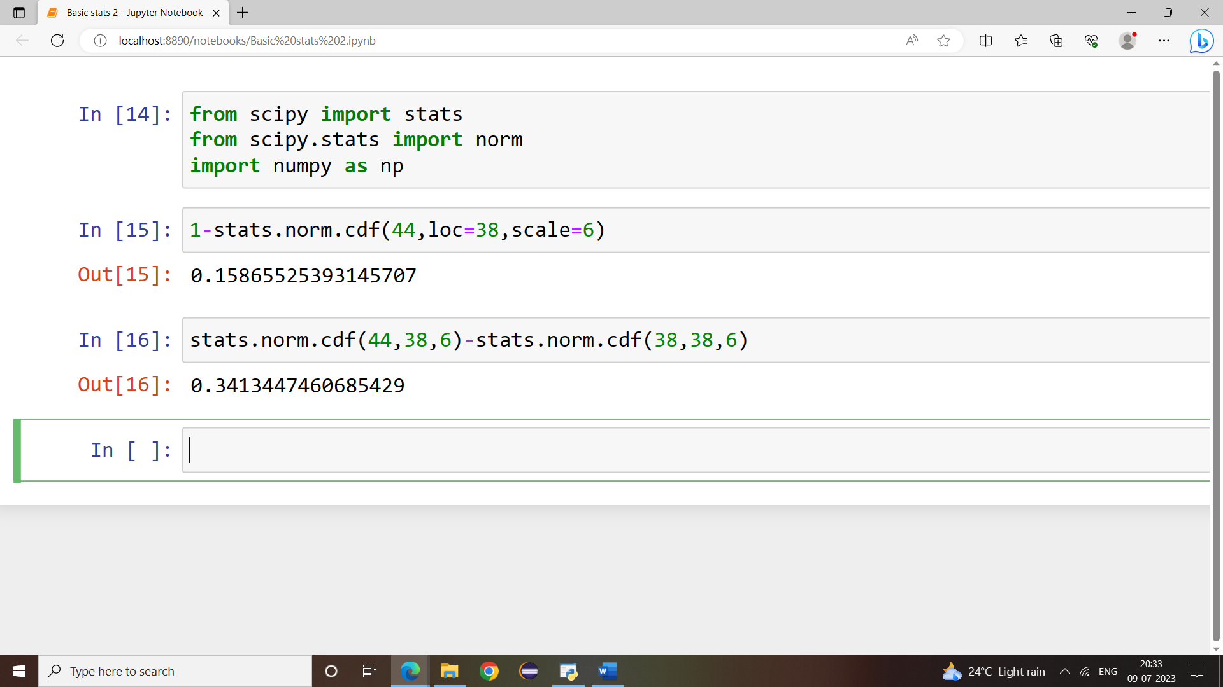

1. If *X1* ~ *N*(μ, σ2) and *X*2 ~ *N*(μ, σ2) are *iid* normal random variables, then what is the difference between 2 *X*1 and *X*1 + *X*2? Discuss both their distributions and parameters.

Ans:-

If X1~ N(μ, σ2)

X2~ *N*(μ, σ2) these are two independent random variables.

2x1:-

2x1~ N(μ1,4 σ2)

X1+X2:-

X1+X2~N(μ1~ μ2, σ2+ σ2)~N(2, μ,2, σ2)

2x1~(1+2x1)=N(4 μ,6 σ2).

1. Let X ~ N(100, 202). Find two values, *a* and *b*, symmetric about the mean, such that the probability of the random variable taking a value between them is 0.99.
2. 90.5, 105.9
3. 80.2, 119.8
4. 22, 78
5. 48.5, 151.5
6. 90.1, 109.9

Ans:- Probability of getting value between a and b is 0.99, so the probability getting outside value a and b is=1-0.99=0.11

Probability towards left of a=-0.01/2=-0.05

Probability towards right of b=0.01/2=0.05

By finding the standard normal variable (z), need to calculate X

Z=(x- μ)/ σ

For a probability of 0.005, z value is -2.57

Z* σ+ μ=x

-(-2.57)*20+100=151.4

(-2.57)*20+100=48

So the answer is option D

1. Consider a company that has two different divisions. The annual profits from the two divisions are independent and have distributions Profit1 ~ N(5, 32) and Profit2 ~ N(7, 42) respectively. Both the profits are in $ Million. Answer the following questions about the total profit of the company in Rupees. Assume that $1 = Rs. 45
2. Specify a Rupee range (centered on the mean) such that it contains 95% probability for the annual profit of the company.
3. Specify the 5th percentile of profit (in Rupees) for the company
4. Which of the two divisions has a larger probability of making a loss in a given year?

